**From:** Mandla Mthombeni [mailto:pmtombeni@gmail.com]   
**Sent:** Tuesday, 07 January 2020 8:41 AM  
**To:** Mtombeni, Mandla <Mandla.Mtombeni@wesbank.co.za>  
**Subject:** Fwd: FW: WBS LEVEL 6 EXAMPLES - [External Email]

---------- Forwarded message ---------  
From: **Mohale, Moloko (MC)** <[Moloko.Mohale@sasol.com](mailto:Moloko.Mohale@sasol.com)>  
Date: Sat, May 6, 2017 at 11:58  
Subject: FW: WBS LEVEL 6 EXAMPLES  
To: Anesh <[murugaa@telkom.co.za](mailto:murugaa@telkom.co.za)>, Atish <[atish.harinath@gmail.com](mailto:atish.harinath@gmail.com)>, Bethuel <[bethuel01@gmail.com](mailto:bethuel01@gmail.com)>, Bothwell <[11601151@myregent.ac.za](mailto:11601151@myregent.ac.za)>, Busi <[busisiwe.malunga@rmb.co.za](mailto:busisiwe.malunga@rmb.co.za)>, Carla ([carla@stratics.co.za](mailto:carla@stratics.co.za)) <[carla@stratics.co.za](mailto:carla@stratics.co.za)>, Carol <[caroline.makhele@joyglobal.com](mailto:caroline.makhele@joyglobal.com)>, Chido <[chikwatac@yahoo.co.uk](mailto:chikwatac@yahoo.co.uk)>, Christine <[sharon.shilenge@mailone.co.za](mailto:sharon.shilenge@mailone.co.za)>, David <[davume@gmail.com](mailto:davume@gmail.com)>, Devi <[devi.farrel@hotmail.co.za](mailto:devi.farrel@hotmail.co.za)>, Isabella ([isabella.liba@vodamail.co.za](mailto:isabella.liba@vodamail.co.za)) <[isabella.liba@vodamail.co.za](mailto:isabella.liba@vodamail.co.za)>, Jaco <[vwykjl@gmail.com](mailto:vwykjl@gmail.com)>, Jacques <[kleynhansjacques@gmail.com](mailto:kleynhansjacques@gmail.com)>, Joakimu <[mandiwona@gmail.com](mailto:mandiwona@gmail.com)>, Kaveer <[kaveer.ramchander@mtn.com](mailto:kaveer.ramchander@mtn.com)>, Keneilwe <[kmorare@gmail.com](mailto:kmorare@gmail.com)>, Keneilwe MBA <[kmorare04@gmail.com](mailto:kmorare04@gmail.com)>, Kishore <[kishore.bharat@gmail.com](mailto:kishore.bharat@gmail.com)>, Ladywana <[ladywana@gmail.com](mailto:ladywana@gmail.com)>, Langton <[jafuredi@yahoo.com](mailto:jafuredi@yahoo.com)>, Liba <[iliba@kagiso.co.za](mailto:iliba@kagiso.co.za)>, Lwando <[lwando.buso@firstrand.co.za](mailto:lwando.buso@firstrand.co.za)>, Mabusha <[m.mabusha@yahoo.com](mailto:m.mabusha@yahoo.com)>, Maluta ([malutam@gmail.com](mailto:malutam@gmail.com)) <[malutam@gmail.com](mailto:malutam@gmail.com)>, Mandla <[pmtombeni@gmail.com](mailto:pmtombeni@gmail.com)>, Manu <[manu.mapila@psa.co.za](mailto:manu.mapila@psa.co.za)>, Marcus <[marcus.rammbuda@gauteng.gov.za](mailto:marcus.rammbuda@gauteng.gov.za)>, Martie ([martie.nortje@mweb.co.za](mailto:martie.nortje@mweb.co.za)) <[martie.nortje@mweb.co.za](mailto:martie.nortje@mweb.co.za)>, Megan <[megan.vercueil@mtn.com](mailto:megan.vercueil@mtn.com)>, Melvin <[melvinmdluli@gmail.com](mailto:melvinmdluli@gmail.com)>, Michael K <[michael_kabai@yahoo.com](mailto:michael_kabai@yahoo.com)>, Minet <[minet@minetroberts.co.za](mailto:minet@minetroberts.co.za)>, Mmantsiki <[mant_mb@hotmail.com](mailto:mant_mb@hotmail.com)>, Mochaki <[mochakimphahlele@gmail.com](mailto:mochakimphahlele@gmail.com)>, Moloko <[mohalemc@gmail.com](mailto:mohalemc@gmail.com)>, Mpho <[msebole6@gmail.com](mailto:msebole6@gmail.com)>, Oarabile <[mabulaoara@gmail.com](mailto:mabulaoara@gmail.com)>, Obakeng <[baksmasilo@gmail.com](mailto:baksmasilo@gmail.com)>, Pat <[patmudimu@gmail.com](mailto:patmudimu@gmail.com)>, Pierre <[psmith@oldmutual.com](mailto:psmith@oldmutual.com)>, R Makhams <[rmakhams@gmail.com](mailto:rmakhams@gmail.com)>, Raisebe <[raisebetema@gmail.com](mailto:raisebetema@gmail.com)>, Raoul <[raoulrugbeer@gmail.com](mailto:raoulrugbeer@gmail.com)>, Reason <[reason_mukosi@hotmail.com](mailto:reason_mukosi@hotmail.com)>, Richardt <[r1manyenje@gmail.com](mailto:r1manyenje@gmail.com)>, Sandy 2 <[sandy.fang0@gmail.com](mailto:sandy.fang0@gmail.com)>, Siphamandla <[siphamandlas@nedbank.co.za](mailto:siphamandlas@nedbank.co.za)>, Sipho <[sntlangula@rocketmail.com](mailto:sntlangula@rocketmail.com)>, Sophie <[mokhonm@telkom.co.za](mailto:mokhonm@telkom.co.za)>, Spha <[ns.sithole@vodamail.co.za](mailto:ns.sithole@vodamail.co.za)>, Tebogo <[tebogo.molefe@drdlr.gov.za](mailto:tebogo.molefe@drdlr.gov.za)>, Temba <[11602151@myregent.ac.za](mailto:11602151@myregent.ac.za)>, Themba <[masimulat@gmail.com](mailto:masimulat@gmail.com)>, Themba2 <[sibusiso.ngwena@gmail.com](mailto:sibusiso.ngwena@gmail.com)>, Thobile <[cath.nkosi@gmail.com](mailto:cath.nkosi@gmail.com)>, Thuliswa <[thuli.nazo@gmail.com](mailto:thuli.nazo@gmail.com)>, Tsibo <[wasa@telkomsa.net](mailto:wasa@telkomsa.net)>, Vanessa <[vmothilal@fnb.co.za](mailto:vmothilal@fnb.co.za)>, Vusi <[Vusi.moyeni@gmail.com](mailto:Vusi.moyeni@gmail.com)>, Will <[willsmithrsa@yahoo.com](mailto:willsmithrsa@yahoo.com)>, Yeb <[demarkusy@outlook.com](mailto:demarkusy@outlook.com)>, Yeb2 <[donbingy@gmail.com](mailto:donbingy@gmail.com)>, Zaida <[zaidadalvie@gmail.com](mailto:zaidadalvie@gmail.com)>, Zolile <[zolilechap@gmail.com](mailto:zolilechap@gmail.com)>

**From:** Marieta Grundling (M) [mailto:[GrundliM@telkom.co.za](mailto:GrundliM@telkom.co.za)]   
**Sent:** 06 May 2017 11:00 AM  
**To:** Will; Mohale, Moloko (MC)  
**Subject:** WBS LEVEL 6 EXAMPLES

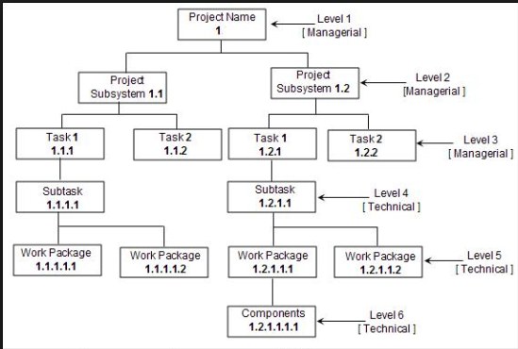

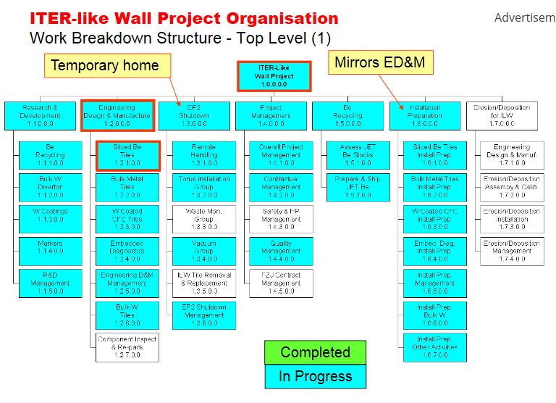

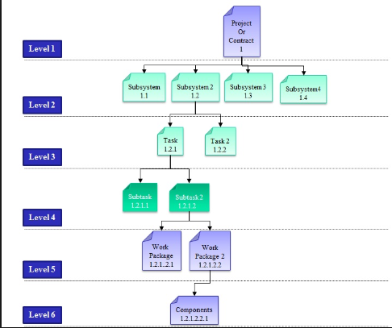

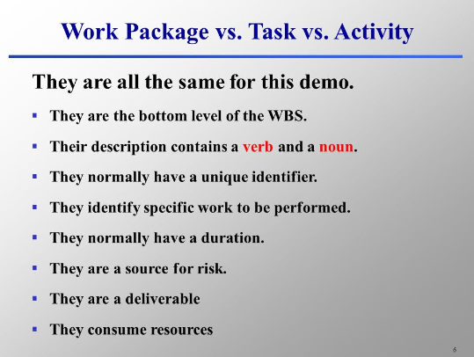

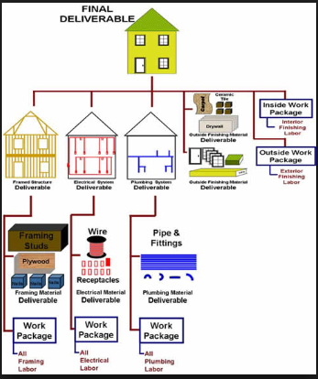

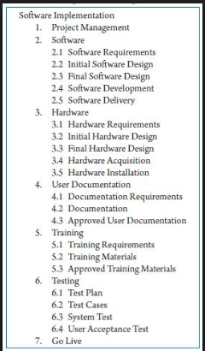

~~~~~~~~~~~~~~~~~~~~~~~~~~~~~~~~~~~~~~~~~~~~~~~~~~~~~~~~~~~~~~~~~~  
This e-mail is subject to the Telkom SA SOC Ltd electronic communication legal notice,   
available at : [http://www.telkom.co.za/TelkomEMailLegalNotice.PDF](http://secure-web.cisco.com/1ggMyL-qANlMy5zJoBzUXUtZzv5Ce9RCpax2Ch8GGoUEap4CqaxDw96OZe8IViPe7Qur-m84HQoRpfA7_3Y0ztBroNF_m2LEk3MqwOweo1w3bUxUttHyO69Ui9gVdxgkTCPEIL6QNFb_unaiAzrolmNXjisAT0SjJT9kHNBSJgwkxMWKTzps5e4Co_OItNfqerqI4V_cRP_XkvByS9ZzGDi5RWw_pb3U5C_Z-sJGwqzU0jjsmK3kUp0jzbeRFfD8pdoxzffZeANOQBQ1cHqp-8VpTomQyDRhh-_L3sN9hqZ3VDyEFz63zdcVar0bknyPrAYHCCsMjKmKJtNoNnOFMsdBtfFpexM8Ji5tteD12t30/http%3A%2F%2Fwww.telkom.co.za%2FTelkomEMailLegalNotice.PDF)  
~~~~~~~~~~~~~~~~~~~~~~~~~~~~~~~~~~~~~~~~~~~~~~~~~~~~~~~~~~~~~~~~~~

NOTICE: This eMail message is from Sasol and is for the sole use of the intended recipient(s), and may contain confidential and/or privileged material.  
If you are not the intended recipient(s), please contact the sender immediately, and destroy all copies of the original message. Any unauthorized review, use, copy, disclosure or distribution is prohibited. Please note that this eMail, and the contents thereof, is also subject to the standard Sasol eMail Legal Notice which may be found at: <http://www.sasol.com/legal-notices>.

disccsa41a3

--

[http://mandla-prettyboy-mthombeni.branded.me](http://secure-web.cisco.com/1QvTkgFnR0v9LL7ndJVREVL1wC61r0tdzmHIOUS3OkmpMe2u6SlJyUs40ByqVzzhpSgqq9-eWyS3qIJu-c7zXUuEj4Ewi30NgyOTTAmbd_NAQkx_wBfQl1sftCSffovLaE6fpAxAMD9vuhK42cUvEQKGkeZwY687nOvziQKMkHRobKqvH-3nfemMUZB5PpZ4yxHnkcNeBdiWexURpHmAWzyopJ340RAMqJRKFflnFVuR8vOWIo5zHvmZYom0Dqdch93ikH1BNyAK1JGW_Sdxm6mBIjRy6AHdq_efzPI1a1tquaTC9XFLUDmZYLA0O-vwApiFBTP9XwwsXCSKyZKT-ww/http%3A%2F%2Fmandla-prettyboy-mthombeni.branded.me)